CinemaCore Systems

Software Requirements Specification

Version 1

19 February 2026

Group #9
Ryann Silverio, Mehar Buttar, William Gray

Prepared for
CS 250- Introduction to Software Systems
Instructor: Gus Hanna, Ph.D.
Spring 2026

Revision History

Date | Description | Author | Comments
2/19/2026 | Version 1 | Group 9 | First Revision
3/5/2026 | Version 1.1 | Group 9 | Second Revision

Document Approval

The following Software Requirements Specification has been accepted and approved by the following:
Signature | Printed Name | Title | Date
 | Group 9 | Software Eng.
 | Dr. Gus Hanna | Instructor, CS 250

Table of Contents

Revision History 2
Document Approval 2
1. Introduction 1
1.1 Purpose 1
1.2 Scope 1
1.3 Definitions, Acronyms, and Abbreviations 1
1.4 References 2
1.5 Overview 3
2. General Description 3
2.1 Product Perspective 3
2.2 Product Functions 4
2.3 User Characteristics 4
2.4 General Constraints 4
2.5 Assumptions and Dependencies 5
3. Specific Requirements 5
3.1 External Interface Requirements 5
3.1.1 User Interfaces 5
3.1.2 Hardware Interfaces 6
3.1.3 Software Interfaces 6
3.1.4 Communications Interfaces 7
3.2 Functional Requirements 7
3.2.1 Functional Requirement #1: Movie Selection and Interactive Seat Reservation 7
3.2.2 Functional Requirement #2: Ticket Purchase, Delivery, and Validation 8
3.2.3 Functional Requirement #3: Virtual Concession Ordering and Seat Delivery 8
3.3 Use Cases 9
3.3.1 Use Case #1: Browse Movies and Reserve Seats 10
3.3.2 Use Case #2: Purchase and Receive Movie Tickets 10
3.3.3 Use Case #3: Order Concessions for Seat Delivery 11
3.3.4 Use Case Diagram 13
3.4 CinemaCore System Classes / Objects 14
3.4.1 CinemaCore System Classes UML Diagram 14
3.4.2 Classes Descriptions 15
3.5 Non-Functional Requirements 15
3.5.1 Performance: 15
3.5.2 Reliability: 16
3.5.4 Security: 16
3.5.5 Maintainability 16
3.5.6 Portability 16
3.6 Inverse Requirements 17
3.6.1 Seat and Booking Constraints 17
3.6.2 Payment and Security Constraints 17
3.6.3 Age-Restricted Content Constraints 17
3.6.4 Concession Ordering Constraints 17
3.6.5 Ticket Delivery Constraints 17
3.6.6 Performance and Access Constraints 17
4. System Overview 18
4.1 Developer System Perspective 18
4.2 Architectural Design 18
4.2.1 Architectural Diagram 18
4.2.2 Architectural Description 18
4.3 Software Architecture (SWA) Design 18
4.3.1 SWA Diagram 18
4.3.2 SWA Description 18
4.4 Development Plan 18
4.4.1 Task Breakdown 18
4.4.2 Project Timeline 18

1. Introduction
The Software Requirements Specification (SRS) introduction presents a comprehensive overview of the document structure, including its purpose, scope, terminology definitions, referenced materials, and organizational framework. This document aims to provide thorough analysis and detailed understanding of the CinemaCore Systems by clearly articulating the system objectives and requirements. Additionally, it focuses on identifying stakeholder capabilities and expectations while establishing the primary product features. Complete and specific requirements for the CinemaCore Systems are documented throughout this specification.

1.1 Purpose
This document serves to gather and evaluate all concepts and requirements that have emerged during system planning, with particular focus on customer needs and expectations. The document aims to clarify intended product usage patterns, enabling deeper project comprehension while documenting both potential features for future development and preliminary ideas that may be refined or eliminated as the system evolves.
Essentially, this SRS document delivers comprehensive details about the software product, including its specifications, objectives, and operational parameters. The document outlines the intended user base, interface design, and technical requirements for both hardware and software components. It establishes a unified vision of the product and its capabilities from the perspectives of clients, development teams, and end users. Moreover, it serves as an essential resource for designers and developers throughout all phases of the software development lifecycle (SDLC).

1.2 Scope
The scope encompasses the CinemaCore System's functionality for deploying a complete theater ticketing and service platform. It addresses theater management needs, stakeholder expectations, and system features that support ticket sales, dynamic pricing, seat selection, virtual concession ordering, and customer interaction across both digital and physical channels.
This SRS aims to define requirements for the software under development, though it may additionally assist in selecting appropriate commercial or in-house software solutions. The specification can be utilized to generate software requirements directly or serve as a template for establishing project-specific or organizational standards. It does not mandate specific methods, naming conventions, or development tools for creating an SRS.

1.3 Definitions, Acronyms, and Abbreviations

Term | Definition
FAQ | Frequently Asked Questions
POS | Point of Sale; the system interface where transactions are completed
API | Application Programming Interface; protocols for software communication
SMTP | Simple Mail Transfer Protocol
SMS | Short Message Service; text messaging
PCI-DSS | Payment Card Industry Data Security Standard
ADA | Americans with Disabilities Act; accessibility compliance standards
MPAA | Motion Picture Association of America; organization that assigns movie ratings
HTTP/HTTPS | Hypertext Transfer Protocol (Secure); protocol used for transmitting web pages and data over the internet with encryption
TCP/IP | Transmission Control Protocol/Internet Protocol; the basic communication language or protocol of the internet
Adyen | Third-party payment processing platform that securely handles online and in-person transactions in compliance with PCI-DSS standards

1.4 References
Adyen. (n.d.). Adyen payments platform. https://www.adyen.com
Apple Inc. (n.d.). Wallet developer documentation. Apple Developer. https://developer.apple.com/wallet/
Google. (n.d.). Google Pay API documentation. Google Developers. https://developers.google.com/pay
IEEE Computer Society. (1998). IEEE recommended practice for software requirements specifications (IEEE Std 830-1998). Institute of Electrical and Electronics Engineers.
Motion Picture Association. (n.d.). Film ratings. https://www.motionpictures.org/film-ratings/
PCI Security Standards Council. (n.d.). Payment Card Industry (PCI) data security standard (PCI DSS). https://www.pcisecuritystandards.org/
World Wide Web Consortium. (2018). Web Content Accessibility Guidelines (WCAG) 2.1. https://www.w3.org/TR/WCAG21/

1.5 Overview
The subsequent sections of this document deliver a comprehensive description, encompassing user characteristics, hardware specifications, and both functional and data requirements for the system. Section 2 discusses the general project description and overall system perspective. Section 3 presents functional requirements, data specifications, design constraints, and assumptions established during CinemaCore System development. This section also captures the user perspective of the product and provides detailed specific requirements including external interface specifications and comprehensive functional requirement descriptions. Section 4 contains analysis models with sequence diagrams, data flow diagrams, and state-transition diagrams for requirement visualization. Section 5 describes the change management process for handling requirement modifications throughout the project lifecycle.

2. General Description
This section presents the problem statement addressing current limitations in traditional movie theater ticketing operations that restrict customer convenience and operational efficiency. It includes identification of stakeholders and end users for the proposed CinemaCore Systems. Additionally, it outlines stakeholder needs and expectations gathered through requirements workshops and analysis sessions. The section lists and describes the primary features and capabilities of the system.
The SRS provides a comprehensive product perspective from various stakeholder viewpoints. It details the product functions of CinemaCore System including user characteristics, design constraints, system assumptions and dependencies, and requirement classifications.

2.1 Product Perspective
CinemaCore System is a comprehensive point-of-sale platform that can be implemented as a standalone solution for new theaters or integrated as an upgrade to existing theater management systems. The system is designed with flexibility to adapt to various theater infrastructures, allowing seamless integration with legacy ticketing systems, scheduling software, and operational databases.
The system interfaces with external payment gateways (Visa, Mastercard, PayPal), digital wallet services (Apple Wallet, Google Pay), email and SMS providers for notifications, tax calculation services, and age verification databases. For theaters with existing food service operations, the system integrates with current point-of-sale systems to coordinate virtual orders with kitchen and delivery operations.
The system supports standard theater hardware including kiosk terminals, receipt printers, barcode scanners, and display monitors. For theaters upgrading from legacy systems, data migration capabilities preserve historical customer information, transaction records, and operational data during platform transition.

2.2 Product Functions
The functions performed by the system are:
- Ticket purchasing and payment processing with discount and surcharge application
- Real-time seat selection and showroom visualization
- Dynamic pricing with tiered seating options (cheaper front sections, premium reserved seating)
- Virtual food ordering with seat delivery coordination
- Customer account creation and profile management
- Email receipt generation and delivery
- Multi-format ticket access (email, SMS, print, digital wallet)
- Timed checkout sessions to ensure fair access during high-demand periods
- Virtual waiting room for managing concurrent ticket purchases
- Age verification for R-rated movies and alcohol purchases
- Ticket counter displaying remaining seat availability per showing
- Showtime reminder notifications
- Ticket transfer functionality for families and resellers
- Physical kiosk support with integrated printer capabilities
- Loyalty points and rewards program
- Movie information management (ratings, showtimes, descriptions)
- Administrative interfaces for theater staff and system management

2.3 User Characteristics
Different user types include:
- Children: Require simple, intuitive interfaces with parental guidance; limited purchasing power
- Teenagers: Tech-savvy, prefer mobile/digital wallets; may need age verification for certain content
- Adults: Primary purchasers; varied technical proficiency; value convenience and speed
- Elderly patrons: May prefer physical tickets and kiosk options; need clear, accessible interfaces with larger text
- Theater staff: Need administrative access for order management, seat checking, food delivery coordination
- System administrators: Technical users managing system configuration, pricing, and maintenance

2.4 General Constraints
Limitations that may affect the development of CinemaCore Systems include:
- Regulatory constraints: PCI-DSS compliance for payment processing; age verification laws for R-rated content and alcohol
- Hardware limitations: Must run on standard theater kiosk hardware with receipt printers
- Internet connectivity: System requires reliable internet for real-time seat updates and payment processing
- Security requirements: Must protect customer payment information and personal data
- Accessibility standards: Must comply with ADA requirements for disabled users
- Browser compatibility: Must support major web browsers (Chrome, Firefox, Safari, Edge)
- Mobile wallet integration: Limited to APIs provided by Apple Wallet and compatible platforms

2.5 Assumptions and Dependencies
Assumptions:
- Users have access to email addresses and phone numbers
- Theater has reliable internet connectivity
- Printers at kiosks are maintained and operational
- Credit card payment gateways are available and functional
- Users have basic computer/smartphone literacy
- Theater staff available to deliver food orders to seats
Dependencies:
- Third-party payment gateway availability (Stripe, PayPal, etc.)
- SMTP server functionality
- Digital wallet API availability (Apple Wallet, Google Pay)
- Age verification service database access
- Tax calculation service availability
- Printer driver compatibility with kiosk hardware
- MPAA ratings accessibility

3. Specific Requirements

3.1 External Interface Requirements

3.1.1 User Interfaces
The system will provide three distinct user interface categories designed for high accessibility and usability across all age groups.
- Customer Web Interface: A responsive web browser application.
  - Dashboard: A full-service view showing movies, ratings, showtimes, and real-time seat availability.
  - Seat Selection Map: A graphical theater preview identifying taken vs. available seats, with color-coded pricing tiers (i.e., discounted front row vs. premium center section)
  - Checkout Flow: A streamlined, timed checkout process with a visible countdown timer.
  - Virtual Concession Stand: An intuitive menu for food and drink selection with a toggle option for “deliver to my seat.”
- Physical Kiosk Interface: A simplified, touch-optimized version of the web interface made for use at the movie theater.
  - Interaction: Large buttons and text for clear and easy navigation.
  - Navigation: Linear flow (Select Movie → Select Time → Select Seats → Payment → Print/Digital Delivery).
- Theater Staff Interface: A management dashboard for real-time operations by theater staff.
  - Food Service View: A management system showing order codes corresponding to theater rooms and seat numbers.
  - Entry Management: A scanning interface for ticket validation and age verification (R-rated movies/alcohol)

3.1.2 Hardware Interfaces
The system will interface with the following physical hardware components:
- Kiosk Terminals: Support for standard touch-screen POS hardware located in theater lobbies.
- Receipt Printers: Standard printers to produce physical tickets and food receipts for guests without digital receipts.
- Barcode/QR Code Scanners: Integration with handheld and fixed scanners to validate virtual and physical tickets.
- Payment Terminals: Connection to physical card readers for tap payment and chip insertions at kiosks.

3.1.3 Software Interfaces
The system will exchange data with the following external software entities:
- Payment Gateways: Secure API connections for credit and debit card processing.
- Digital Wallet APIs: Integration with Apple Wallet and Google Pay for pushing virtual tickets to user devices.
- Notification Services: For sending emailed receipts and account verification links.
  - SMS Gateway: For sending showtime reminders and phone-based ticket links.
- Age Verification Service: API to databases or ID scanning software to validate age for R-rated movies and alcohol sales.
- Tax Calculation API: Connection to a third-party service for real-time localized tax application on tickets and concessions.

3.1.4 Communications Interfaces
To ensure data integrity and security, the system will utilize the following communication protocols:
- HTTP/HTTPS: All web traffic shall be encrypted using standard HTTP/HTTPS.
- TCP/IP: For local communication between kiosk hardware, printers, and the theater’s central server.
- Real-Time Synchronization: Use of WebSockets or long-polling for updating seat availability and virtual waiting room status for all concurrent users.

3.2 Functional Requirements
This section defines the core functions and behaviors that CinemaCore Systems must perform to meet user and stakeholder needs. Each functional requirement specifies system inputs, processing logic, outputs, and error handling associated with a particular feature. These requirements describe what the system must do and serve as the primary basis for use case development, system design, and requirement validation.

3.2.1 Functional Requirement #1: Movie Selection and Interactive Seat Reservation

3.2.1.1 Introduction: This feature allows the user to browse movies, view showtimes, and select specific seats from a virtual representation of the movie theater. It incorporates dynamic pricing based on seat location and manages a timed checkout.

3.2.1.2 Inputs: User selection for specific movie, date, and time.
- Seat Locations: User selected seats from the graphical theater map.
- User Age: Tickets categorized by age for initial pricing.
- Checkout Timer: Reservation timer activated on first seat selection.

3.2.1.3 Processing: Real-time seat availability check in the database.
- Tiered Pricing: The system will apply a surcharge for premium sections and will apply a discount for front row seating.
- Seat Locking: Upon selection, the system will temporarily lock the seats from other customers for 10 minutes. If the seats are purchased, the system will permanently lock the seats unless refunded.
- User Traffic Management: If high traffic is detected, the system will place subsequent users in a virtual waiting room queue before allowing seat selection.

3.2.1.4 Outputs: Real-time updates of theater maps showing selected seats as “Pending Purchase.”
- Price Summary: A breakdown of base price, location-based surcharges and discounts, and age-based discounts.
- Countdown Timer: A visible 10 minute timer displayed for the user to see.

3.2.1.5 Error Handling: If the 10 minute timer hits zero, the system will release the locked seats, clear the user’s cart, and notify the user via a pop-up message.

3.2.2 Functional Requirement #2: Ticket Purchase, Delivery, and Validation

3.2.2.1 Introduction: This feature allows customers to securely purchase movie tickets and receive them in multiple formats, including digital and physical options. Tickets must be uniquely identified and verifiable at theater entry points.

3.2.2.2 Inputs: Confirmed user selected seats and user information
- Selected seats: Confirmed selected seats
- Payment information: Credit/debit card or digital wallet
- Form of contact: Email address and/or phone number
- Option to save info: Optional login credentials with email and password

3.2.2.3 Processing: Real-time payment and account validation
- Secure payment: The system shall securely process payments in compliance to PCI-DSS standards
- Unique Ticket Identifier: Upon successful payment, the system will generate a unique ticket identification number and associated barcode
- Ticket Linkage: The system shall link purchased tickets to the associated screening room, showtime, and seat number

3.2.2.4 Outputs: Summary of purchases and options for digital or physical forms
- Purchase Receipt: Confirmation receipt detailing purchase information, cost, payment used, and seats
- Digital Ticket: A digital ticket sent via email, SMS, and/or digital wallet
- Printed Ticket: Optional printed ticket generated at physical kiosk locations

3.2.2.5 Error Handling:
- If the payment authorization fails, the system shall cancel the transaction, release the locked seats, and display an appropriate error message
- If ticket delivery fails, the system shall retry delivery and provide the user with an on-screen recovery option

3.2.3 Functional Requirement #3: Virtual Concession Ordering and Seat Delivery

3.2.3.1 Introduction: This feature allows customers to browse, purchase, and manage concession items digitally as part of the movie ticketing experience. This feature enables customers to order food and beverages in advance or during the movie, and have items delivered directly to their seats

3.2.3.2 Inputs: Food items, digital movie ticket identifier, and user payment info
- Concession: Selected food and beverage items, as well as quantity of each
- Ticket: Contains seat location and screening room
- Confirmation: Status that payment has been confirmed

3.2.3.3 Processing: Real-time payment and account validation, and food availability and cost
- Menu: The system shall display real-time concession items on a menu, with current pricing and availability
- Linkage to Ticket Identifier: Upon successful payment, the system will link the concession items to the user’s ticket identifier
- Food Transmission: The system shall transmit food orders to the theater staff interface with order status indicators (e.g. Received, In Preparation, Out for Delivery)
- Age Verification: The system shall enforce age verification for alcoholic beverages in compliance with local regulations
- Cutoff Time: The system shall prevent concession orders once a predefined cutoff time during the movie has been reached

3.2.3.4 Outputs: Summary of purchases with estimated delivery time, as well as order status
- Purchase Receipt: Confirmation receipt detailing purchase information, cost, payment used, and seats, and delivery estimated time of arrival
- Digital Receipt: A digital receipt sent via email and a summary of orders available through user interface
- Order Status: Real-time status updates available through the customer interface
- Printed Receipt: Optional printed receipt delivered to customer with food, option to print is available through the customer interface

3.2.3.5 Error Handling:
- If a selected item becomes unavailable, the system shall notify the user and prompt for a replacement or removal
- If order transmission fails, the system shall retry delivery and alert theater staff if manual intervention is required

3.3 Use Cases
This section outlines the primary use cases of the system, describing how users and external entities interact with the system to achieve specific goals. Each use case defines the sequence of actions between the actor and the system, providing a functional view of the system’s behavior and serving as a basis for validating requirements and guiding system design and implementation.

3.3.1 Use Case #1: Browse Movies and Reserve Seats
This use case describes how a customer selects a movie and showtime, views real-time seat availability, and reserves seats using an interactive theater layout with dynamic pricing and a timed checkout process.

3.3.1.1 Associated Requirement:
- FR-1: Movie Selection and Interactive Seat Reservation
3.3.1.2 Primary Actor:
- Adult customer
3.3.1.3 Basic Flow:
- The customer accesses CinemaCore Systems via web or kiosk
- The customer browses available movies and selects a showtime
- The system displays a graphical seat map with real-time availability
- The customer selects one or more seats
- The system applies tiered pricing based on seat location
- The system locks the selected seats and starts the 10-minute checkout timer
3.3.1.4 Alternative Flow:
- If the system traffic is high, the system will place the customer in a virtual waiting room until access becomes available
3.3.1.5 Preconditions:
- The system is online and operational
- Movies and Showtimes are available
3.3.1.6 Postconditions:
- Selected seats are temporarily locked for the customer
- A checkout timer is activated
3.3.1.7 Special Requirements:
- Seat availability must update in real-time across all users
- The interface must comply with ADA accessibility requirements
- Seat-locking must prevent double-booking under concurrent access

3.3.2 Use Case #2: Purchase and Receive Movie Tickets
This use case outlines the process by which a customer completes payment for reserved seats, receives tickets in digital or physical formats, and obtains a confirmation receipt for theater entry.
3.3.2.1 Associated Requirement:
- FR-2: Ticket Purchase, Delivery, and Validation
3.3.2.2 Primary Actor:
- Adult customer
3.3.2.3 Basic Flow:
- The customer enters payment and contact information
- The system securely processes the payment
- The system generates a unique ticket identifier and barcode
- The system delivers tickets via email, SMS, digital wallet, or kiosk printer
- The system sends a purchase confirmation receipt
3.3.2.4 Alternative Flow:
- The customer selects physical ticket printing at a theater kiosk
3.3.2.5 Preconditions:
- Seats have been selected and locked
- Customer has a valid payment method
3.3.2.6 Postconditions:
- Tickets are generated and delivered in selected format
- Seats are permanently reserved for the showtime
3.3.2.7 Other Stakeholders:
- Payment processors
- Theater entry staff
- Compliance auditors
3.3.2.8 System/subsystem:
- Payment processing subsystem
- Ticket generation subsystem
- Notification and delivery subsystem
- Ticket validation subsystem
3.3.2.9 Special Requirements:
- Payment processing must comply with PCI-DSS standards
- Tickets must be uniquely identified and non-duplicate
- Digital tickets must be scannable both online and offline at theater entry points

3.3.3 Use Case #3: Order Concessions for Seat Delivery
This use case details how a customer orders food and beverages through the system, links the order to a specific seat and ticket, and receives in-seat delivery coordinated by theater staff.
3.3.2.1 Associated Requirement:
- FR-3: Virtual Concession Ordering and Seat Delivery
3.3.2.2 Primary Actor:
- Adult customer
3.3.2.3 Basic Flow:
- The customer browses the virtual concession menu
- The customer selects food and beverage items
- The system links the order to the customer’s ticket and seat
- The customer confirms the order
- The system sends the order to the theater staff interface
- Theater staff prepares and delivers the order
3.3.2.4 Alternative Flow:
- The customer schedules the order for delivery before the movie starts
3.3.2.5 Preconditions:
- Customer has a valid ticket for showtime
- Concession services are enabled for the theater
3.3.2.6 Postconditions:
- Food is delivered to the correct seat
- Order status is marked as completed
3.3.2.7 Other Stakeholders:
- Theater Operations Management
- Health and Safety Inspectors
3.3.2.8 System/subsystem:
- Virtual Concession subsystem
- Order management subsystem
- Staff operations interface
3.3.2.9 Special Requirements:
- Alcohol purchases require age verification
- Orders must include clear seat and theater identifiers for delivery accuracy
- Order status updates must be visible to both customers and staff in real-time

3.3.4 Use Case Diagram
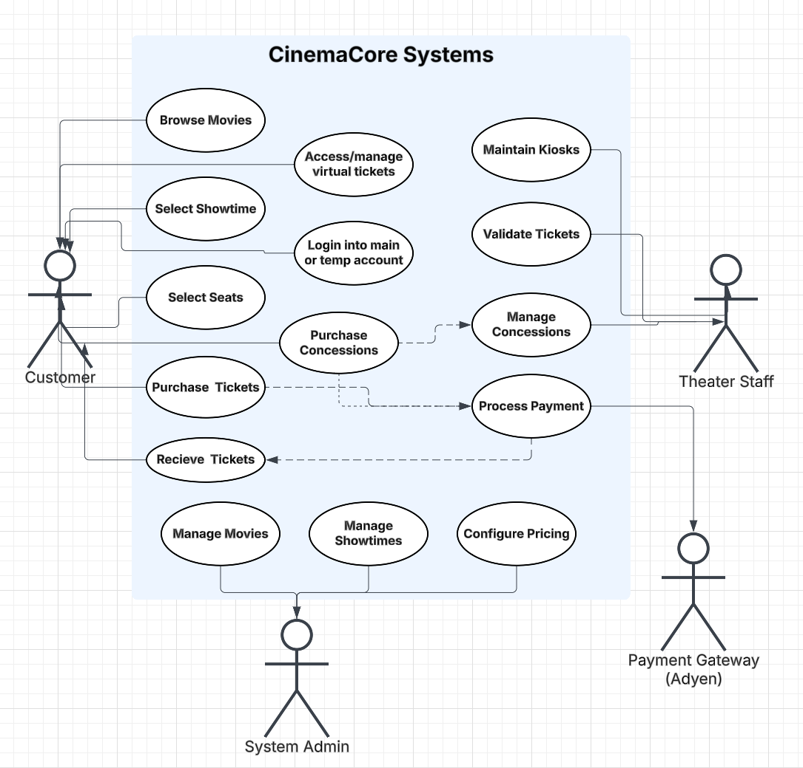

3.4 CinemaCore System Classes / Objects

3.4.1 CinemaCore System Classes UML Diagram
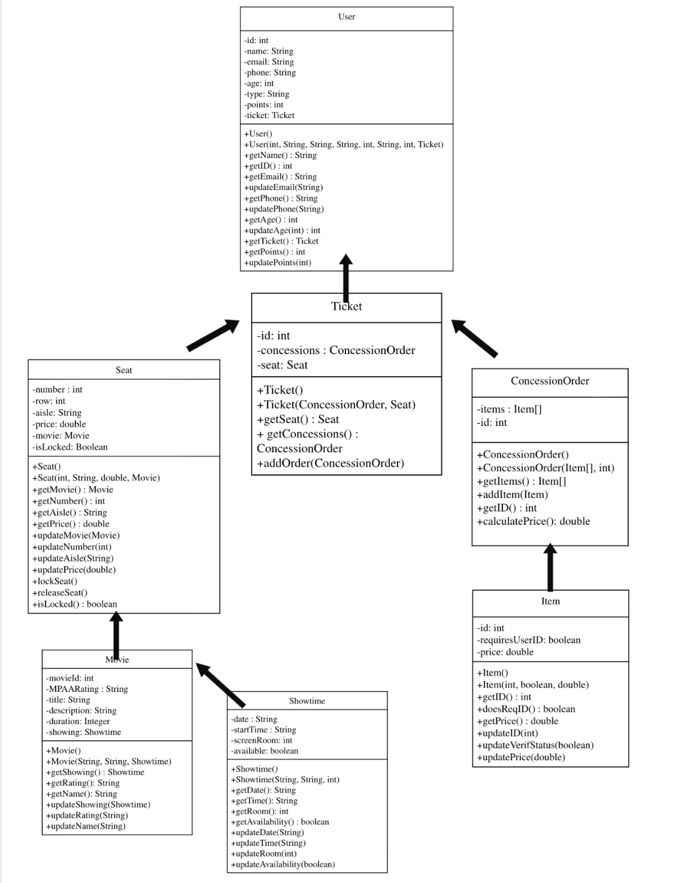

3.4.2 Classes Descriptions
3.4.2.1 User
Represents a cinema system user. Stores personal information (name, email, phone, age), account details (type, points), and their associated Ticket. Provides getters/setters for all fields plus point management.
3.4.2.2 Ticket
The core transaction object linking a User to their seat and concession order. Holds a reference to a Seat and a ConcessionOrder, and supports adding new concession orders after creation.
3.4.2.3 Seat
Represents a physical seat in the cinema. Tracks its location (row, aisle, number), price, the Movie being shown, and whether it's currently locked/reserved. Supports locking and releasing seats to manage availability.
3.4.2.4 Movie
Represents a film in the system. Stores the title, MPAA rating, description, duration, and its associated Showtime. Provides update methods for all fields.
3.4.2.5 Showtime
Represents a scheduled screening. Tracks the date, start time, screen room number, and whether the showing is still available for booking.
3.4.2.6 ConcessionOrder
Represents a food/drink order attached to a ticket. Contains a list of Items and an order ID, and can calculate the total price of all items in the order.
3.4.2.7 Item
Represents an individual concession item. Stores its price, ID, and a flag indicating whether it requires user ID verification (e.g. alcohol). Supports updating price and verification status.

3.5 Non-Functional Requirements
This section specifies the quality attributes and operational constraints that CinemaCore Systems must satisfy. Non-functional requirements address system-wide characteristics such as performance, reliability, availability, security, maintainability, and portability. These requirements define how well the system must operate and establish measurable criteria used to evaluate system effectiveness and compliance.

3.5.1 Performance:
- The system should not have noticeable delays when transferring ticket selection data or updating seat availability. Seat availability must update in real time across all users so that double-booking does not occur.
- The system requires a constant connection to the main server that stores ticketing information. A stable network connection is necessary for real-time seat updates and payment processing. To reduce latency, the system should be optimized to minimize unnecessary network traffic between kiosks and the central server.
- At least 95% of checkout transactions (from payment submission to confirmation) should be processed in less than one second, excluding delays caused by external payment providers such as Adyen.

3.5.2 Reliability:
- The software must reliably prevent double-booking under all conditions. Once a seat is locked or purchased, it must not be available to other users unless the hold expires or a refund is processed.
- If a network issue occurs, the system may operate in a limited offline mode at kiosk locations. In this mode, tickets may be printed physically on-site, but digital delivery features may be unavailable until the network connection is restored.
- The system should maintain an uptime target of 99.9% during theater operating hours, excluding scheduled maintenance.
3.5.3 Availability:
- The system must remain accessible during all standard theater operating hours.
- Multiple kiosks at each location should ensure that ticket purchasing remains available even if one kiosk experiences a hardware issue.
- Planned maintenance should be scheduled during non-peak hours to minimize disruption to customers.

3.5.4 Security:
- The system must protect customer data and payment information at all times.
- All web traffic must be encrypted using HTTPS.
- Payment processing will be outsourced through Adyen in compliance with PCI-DSS standards. The system will not store full credit card information locally.
- Administrative access will require secure login credentials, and only authorized staff will be able to modify showtimes, pricing, and availability.

- Tickets purchased without a registered account can be accessed using the email address provided at checkout and a temporary access code sent to that email.
- CAPTCHA and queue-based traffic control mechanisms will be used to prevent bot activity during high-demand events.

3.5.5 Maintainability
- The system should be designed so that pricing, showtimes, and seat availability can be updated through the admin interface
- Basic hardware issues should be diagnosable by theater staff, with maintenance techs available when necessary.

3.5.6 Portability
- The customer interface must function across major web browsers (Chrome, Firefox, Safari, Edge).
- The kiosk version must be compatible with standard touchscreen POS hardware used in theaters.
- After purchase, tickets must be easily accessible on mobile devices via email, SMS link, or digital wallet, even if originally purchased at a kiosk.

3.6 Inverse Requirements
This section defines behaviors and actions that the CinemaCore System must explicitly never perform. These requirements serve as constraints that bound acceptable system behavior and are derived directly from the functional and non-functional requirements defined in this document.

3.6.1 Seat and Booking Constraints
The system shall not:
- Allow a seat to be selected or purchased by another user while it is temporarily locked or permanently reserved.
- Permanently lock a seat if payment was not completed or the 10-minute checkout timer has expired.
- Generate duplicate tickets for the same seat and showtime under any circumstances.

3.6.2 Payment and Security Constraints
The system shall not:
- Store full credit card numbers or sensitive cardholder data locally on any kiosk terminal or central server.
- Process any payment transaction outside of PCI-DSS compliant encryption standards.
- Grant administrative access to pricing, showtimes, or seat availability without verified staff credentials.

3.6.3 Age-Restricted Content Constraints
The system shall not:
- Permit the purchase of R-rated movie tickets or alcoholic concession items without successful age verification.
- Bypass age verification requirements regardless of user account type, loyalty status, or purchase history.

3.6.4 Concession Ordering Constraints
The system shall not:
- Accept new concession orders after the predefined cutoff time during an active screening.
- Link a concession order to a seat that does not have a valid, confirmed ticket associated with it.

3.6.5 Ticket Delivery Constraints
The system shall not:
- Mark a ticket as successfully delivered if the email, SMS, or digital wallet transmission has failed without a confirmed successful retry.

3.6.6 Performance and Access Constraints
The system shall not:
- Permit unchecked automated bot activity during high-demand ticket release periods.
- Allow modifications to showtimes, pricing, or seat availability without administrator authentication.

4. System Overview
This section presents the CinemaCore System from a developer perspective, describing the system's internal structure, component relationships, and technical implementation strategy. It provides the architectural foundation necessary for development teams to understand how system components interact and how the platform is organized for implementation and maintenance.

4.1 Developer System Perspective

4.2 Architectural Design

4.2.1 Architectural Diagram

4.2.2 Architectural Description

4.3 Software Architecture (SWA) Design

4.3.1 SWA Diagram

4.3.2 SWA Description

4.4 Development Plan

4.4.1 Task Breakdown

4.4.2 Project Timeline
- timeline/Gantt chart goes here

To do:
- overview of system from perspective of the developer
- architectural diagram + description + title
- swa diagram + description + title
- development plan for tasks and timeline
- github repo

